**GIT**

**HOL - 5**

**Execute steps involving clean up and push back to remote Git.**

**Step 1 – Create a New Local Repo**

# Create a folder for your repo

mkdir GitCleanupDemo

cd GitCleanupDemo

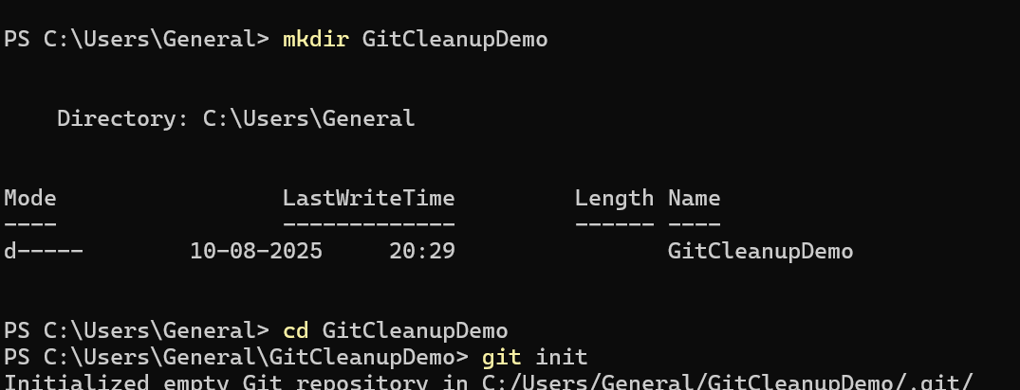

git init

git branch

**Step 2 – Link to GitLab Remote**

1. Sign in to GitLab.
2. Click **New Project** -> GitCleanupDemo.
3. Copy the HTTPS or SSH URL.

git remote add origin https://gitlab.com/username/GitCleanupDemo.git

**Step 3 – Add Initial Files & Commit**

echo "Initial file" > readme.txt

git add readme.txt

git commit -m "Initial commit"

git push -u origin main

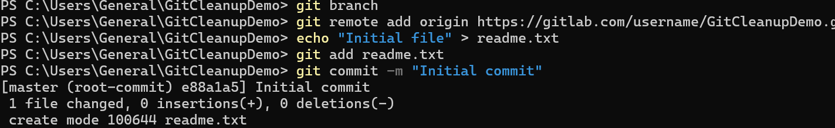

**Step 4 – Create & Merge a Temporary Branch**

git checkout -b temp-branch

echo "Temp work" > temp.txt

git add temp.txt

git commit -m "Added temp work"

# Merge into main

git checkout main

git merge temp-branch

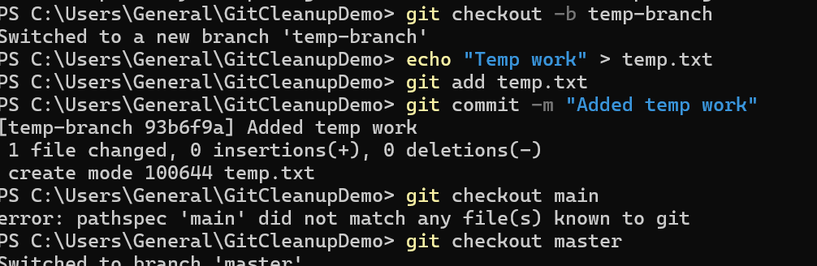

**Step 5 – Cleanup: Delete Branch**

git branch -d temp-branch

git fetch --prune

**Step 6 – Remove Untracked Files**

git clean -fd

**Step 7 – Push Final State to Remote**

git push origin main

**Step 8 – Verify**

git status

git log --oneline --graph --decorate --all

